Penetration Testing Report:

General Scan information:

|  |  |  |  |
| --- | --- | --- | --- |
| Website | No. Of URL's Tested | No. Of Successful Attacks | Time Taken |
| Juice_Shop | 609 | 0 | 11 Seconds |

Website Vulnerability Statuses:

|  |  |
| --- | --- |
| Website | Safety |
| Juice_Shop | Website Secure! |

Juice_Shop

Date and Time of Report: 12-05-2023, 16:26:41

Vulnerability Statistics:

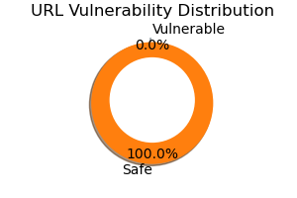

Recommendations:

Nothing To Recommend, Your Webpage is Secure!